THE SOUTH AFRICAN COUNCIL FOR THE LANDSCAPE ARCHITECTURAL PROFESSION (SACLAP)
ANNOUNCES ITS NEW COUNCIL FOR THE PERIOD 2022-2026

The South African Council for the Landscape Architectural Profession (SACLAP) is happy to announce its new Council, as appointed by the Honourable Minister of the Department of Public Works and Infratructure, Mrs Patricia De Lille. The new Council members will serve a four year term of office from 4 March 2022 to 3 March 2026 and are as follows:

No. | Statutory Category | Appointed Members
 | Section3(1)(a) – Registered Professionals
1 |  | Mrs Landie Meyer
2 |  | Mr Willie Mothowamodimo
3 |  | Mr Bonga Mthembu
4 |  | Mr Johan Van Rooyen
5 |  | Dr Kara-Lee Prinsloo
6 |  | Mr Mashudu Gavhi
 | Section 3(1)(b) – State Representatives
7 |  | Mr Edward Hutamo
8 |  | Mr Aphelele Cengimbo
 | Section 3(1)(c) – Public Representatives
9 |  | Keitumetse Mahlangu
10 |  | Lesego Maseko

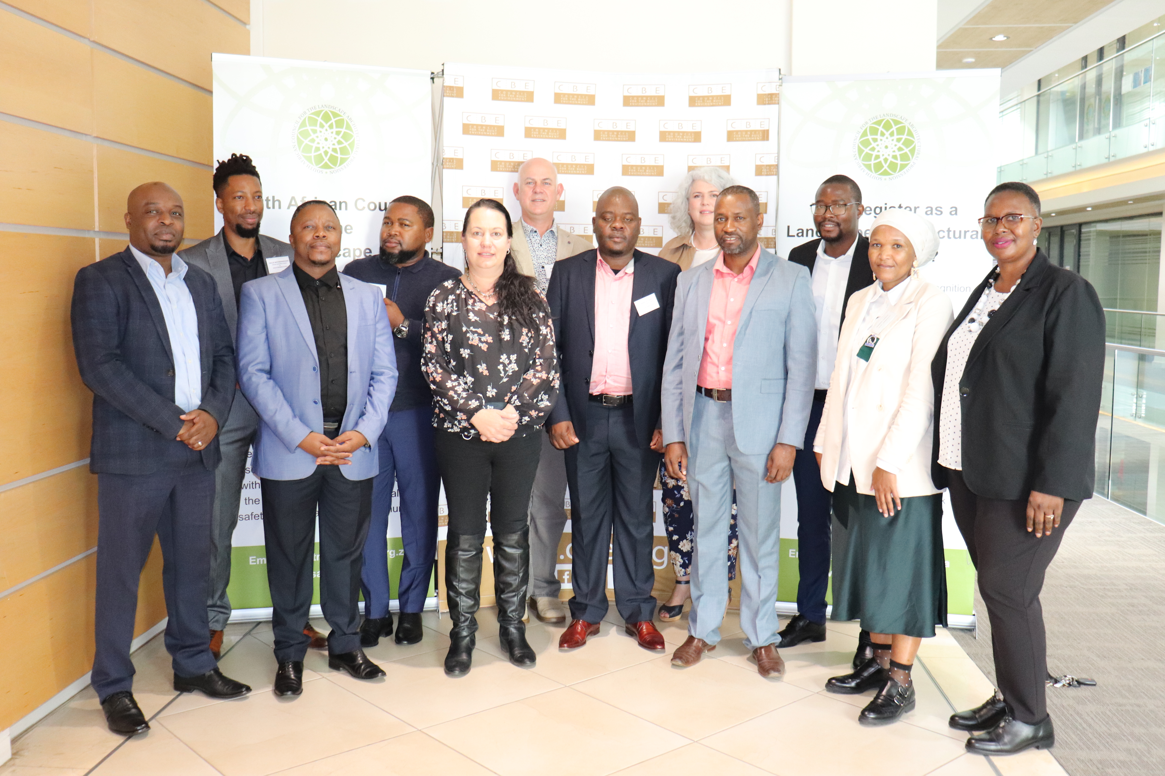
Back (Left to Right): Mr Willie Mothowamodimo, Mr Thabo Munyai, Mr Frans van Wyk, Ms Landie Meyer, Mr Lawrence Nevondo (DPWI)
Front(Left to Right): Mr Mpho Mashaba(DPWI) Mr Molatelo Mohwasa(DPWI) Dr Kara Lee Prinsloo, Mr Edward Hutamo, Mr Mashudu Gavhi, Ms Phindile Tsepetsi, Ms Cecilia Chinga

Councillor Mr Ngwako Edward Hutamo, PrLM; and Councillor Mr Aphelele Cengimbo,PrLArch; were elected President and Vice President respectively.

