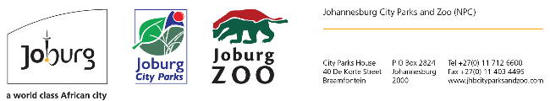
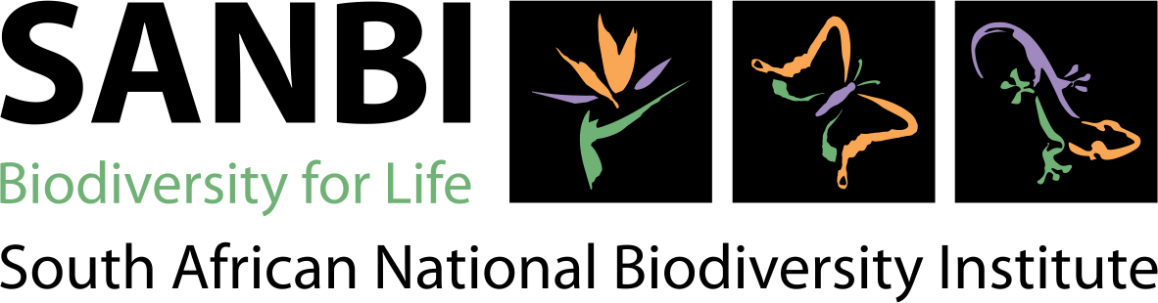
GROEN SEBENZA PHASE II

Call for Two Year Internships

The Groen Sebenza Phase II Programe is a bridging into work programme funded for the next three years. GS Phase aims to recruit 1050 unemployed graduates (diploma - PHD) and place them nationally in different organisations (government and non-governmental) where they will be incubated (trained and mentored) to further develop their competence and confidence in the management of environment/biodiversity. The programme goals

- Enable workplace-based learning for graduates aimed at building and strengthening their capacity at various levels.
- Creation of job opportunities and possible permanent placement beyond funding.
- Transformation and organisational strengthening - strengthen different organisational development aspects including transformation in its totality, mentoring, proactive skills and planning to better respond to organisational mandates and other national priorities.
- Research informed - through research, develop a ‘live’ skills intelligence system that will enable the sector to proactively plan for skills development and track and trace the utilisation of the developed skills.

Johannesburg City Parks & Zoo in partnership with The South African National Biodiversity Institute (SANBI) is pleased to announce a call for applications for incubation in the following fields:

Field | Location (Where the Intern will be based) | Required Qualification | Number required | Stipend rate
Ecotourism | Botanical Gardens in Emmarentia, Johannesburg Zoo in Parkview and Zoo Farm in Parys | Diploma/Degree in Ecotourism | 3 | R6 082.00 - R7 359.00
Hydrology | Ferndale Depot in Randburg – Integrated Catchment Management | Degree/Diploma/Honours/Masters in Hydrology | 1 | R6 082.00 - R10 035.00
Water Sciences | Ferndale Depot in Randburg – Integrated Catchment Management | Degree/Diploma/Honours/Masters in Water Sciences | 1 | R6 082.00 - R10 035.00
Development Studies | Johannesburg Botanical Gardens in Emmarentia | Degree/Diploma/Honours/Masters Development Studies | 1 | R6 082.00 - R10 035.00
Zoology | Johannesburg Zoo in Parkview | Degree/Diploma/Honours/Masters in Zoological Studies | 2 | R6 082.00 - R10 035.00
Veterinary Services | Johannesburg Zoo in Parkview | Diploma/Degree/Honours/Masters in Veterinary Services | 2 | R6 082.00 - R10 035.00
Botany | Johannesburg Botanical Gardens in Emmarentia | Degree/Diploma in Botany | 2 | R6 082.00 - R10 035.00
Project Management | Johannesburg Zoo – Capital Infrastructure Department in Parkview | Degree/Diploma in Project Management/Landscaping | 2 | R6 082.00 - R7 359.00

Requirements
- Must be a SA citizen.
- young unemployed and underemployed professionals between the ages of 18 and 35.
- Innovative, dynamic and creative
- A commitment to a career development in the environmental/biodiversity sector.
- Must hold qualifications mentioned in table above
- People with disabilities are also encouraged to apply.

Internship monthly stipend values (no other benefits apply as these are internship positions)
- Diploma completed (or equivalent to NQF 6): R6 082.00
- Bachelors completed (or equivalent to NQF 7): R7 359.00
- Honours completed (or equivalent to NQF 8): R8 697.00
- Masters completed (or equivalent to NQF 9): R10 035.00

Candidates holding higher qualifications than the ones stated in the above fields may apply, however only remuneration stated per field will be applicable.

Application procedure
Email CVs with certified copies of qualifications and ID to GroenSebenza@jhbcityparks.com

Contact Person: Sinah Magolo
Tel: 079 8981 761

Closing date: 13/02/2023

SANBI reserves the right not to fill these internships.

If no response has been received within 40 days of the closing date, candidates may assume that their applications were unsuccessful.

